Week 7: The word of truth – Jeremiah 25:1-29

Pray for our mission partners and your time in the Word
Context
- What was something interesting from the sermon on Sunday?  Read Jeremiah 25:1-7  - Jeremiah vs: 3 said he has been preaching for 23 years, how would you describe what he has been preaching?  - How have they received Jeremiah's message? | Jeremiah 25  Sound of millstones: used to grind flour, the sound often would announce a new day, a lack of this sound represented curse, daily substance in danger.  the king of Sheshak: another way of describing Babylon.  Jeremiah 28  Yoke of Babylon: a metaphor for describing a burden (farm language), in this case the burden being captivity to Babylon.  Gibeon: north of Jerusalem, near Jeremiah's home town
Notice
Read Jeremiah 25:  - Re-read the passage on your own | Prompts for reading on own  - Images/metaphors  - Keywords or ideas  - Questions you have
- Share with a partner, what images had an impact on you?  - Discuss all together,  - What are you unsure about?  - What do you think the passage is about?  Resolve what you think the main point of the passage is? | Guided study if needed  Vs: 8-11, what is the consequence of Judah’s refusal to listen?  - How has the servants Gods sned changed from vs: 1-4  - What are the implications of exile that lasts 70 years?  Vs: 12-14, Why does God bring judgement on the surrounding nations as well?  15-29, what does the symbol of the cup represent?  - Is there a way of escaping drinking from this cup?
Read Jeremiah 28 | Vs: 1-4, What’s similar and different about Hananiah's prophecy?  Vs: 5-9, What is Jeremiah's defence? How can we know what's true?  Vs: 10-17, what's the consequences of Hananiah prophesying flashing in the LORD’s name?  - What does this mean for Jeremiah prophecy in Jer 25?
Reflect
- As a group,  - What are some life lessons?  - What do these chapters teach about God?  - Resolve what you think the main message | Guided study if needed  What's a way you can test whether a prophecy is true or not?  What does this teach about how humanity treats uncomfortable truths?  What does this teach us about God's judgement and forgiveness?  Read Matthew 26:36-39, how does Jeremiah 25 help us understand what was paid for our salvation?
Respond
- What kind of impact should it have? On  - What you believe  - What you want in life  - What you do this week | Are we in danger of softening God's word to fit our culture?  If every word in the bible about the future will be fulfilled, how would that affect our lives now?
Pray in response to the passage, then in pairs

MP: God vindicates Jeremiah as the true prophet whose words will be fulfilled in the pouring out of God’s wrath on Judah and the nations.

App: God’s word is always fulfilled, which means there is future hope in Christ who bore God's wrath for our salvation, and also future Judgment that will come.
25 The word came to Jeremiah concerning all the people of Judah in the fourth year of Jehoiakim son of Josiah king of Judah, which was the first year of Nebuchadnezzar king of Babylon. ² So Jeremiah the prophet said to all the people of Judah and to all those living in Jerusalem: ³ For twenty-three years—from the thirteenth year of Josiah son of Amon king of Judah until this very day—the word of the Lord has come to me and I have spoken to you again and again, but you have not listened.
⁴ And though the Lord has sent all his servants the prophets to you again and again, you have not listened or paid any attention. ⁵ They said, “Turn now, each of you, from your evil ways and your evil practices, and you can stay in the land the Lord gave to you and your ancestors for ever and ever. ⁶ Do not follow other gods to serve and worship them; do not arouse my anger with what your hands have made. Then I will not harm you.”
⁷ “But you did not listen to me,” declares the Lord, “and you have aroused my anger with what your hands have made, and you have brought harm to yourselves.”
⁸ Therefore the Lord Almighty says this: “Because you have not listened to my words, ⁹ I will summon all the peoples of the north and my servant Nebuchadnezzar king of Babylon,” declares the Lord, “and I will bring them against this land and its inhabitants and against all the surrounding nations. I will completely destroy them and make them an object of horror and scorn, and an everlasting ruin. ¹⁰ I will banish from them the sounds of joy and gladness, the voices of bride and bridegroom, the sound of millstones and the light of the lamp. ¹¹ This whole country will become a desolate wasteland, and these nations will serve the king of Babylon seventy years.
¹² “But when the seventy years are fulfilled, I will punish the king of Babylon and his nation, the land of the Babylonians,^{[b]} for their guilt,” declares the Lord, “and will make it desolate forever. ¹³ I will bring on that land all the things I have spoken against it, all that are written in this book and prophesied by Jeremiah against all the nations. ¹⁴ They themselves will be enslaved by many nations and great kings; I will repay them according to their deeds and the work of their hands.”

The Cup of God’s Wrath
¹⁵ This is what the Lord, the God of Israel, said to me: “Take from my hand this cup filled with the wine of my wrath and make all the nations to whom I send you drink it. ¹⁶ When they drink it, they will stagger and go mad because of the sword I will send among them.”
¹⁷ So I took the cup from the Lord’s hand and made all the nations to whom he sent me drink it: ¹⁸ Jerusalem and the towns of Judah, its kings and officials, to make them a ruin and an object of horror and scorn, a curse^{[c]}—as they are today; ¹⁹ Pharaoh king of Egypt, his attendants, his officials and all his people, ²⁰ and all the foreign people there; all the kings of Uz; all the kings of the Philistines (those of Ashkelon, Gaza, Ekron, and the people left at Ashdod); ²¹ Edom, Moab and Ammon; ²² all the kings of Tyre and Sidon; the kings of the coastlands across the sea; ²³ Dedan, Tema, Buz and all who are in distant places^{[d]}; ²⁴ all the kings of Arabia and all the kings of the foreign people who live in the wilderness; ²⁵ all the kings of Zimri, Elam and Media; ²⁶ and all the kings of the north, near and far, one after the other—all the kingdoms on the face of the earth. And after all of them, the king of Sheshak^{[e]} will drink it too.
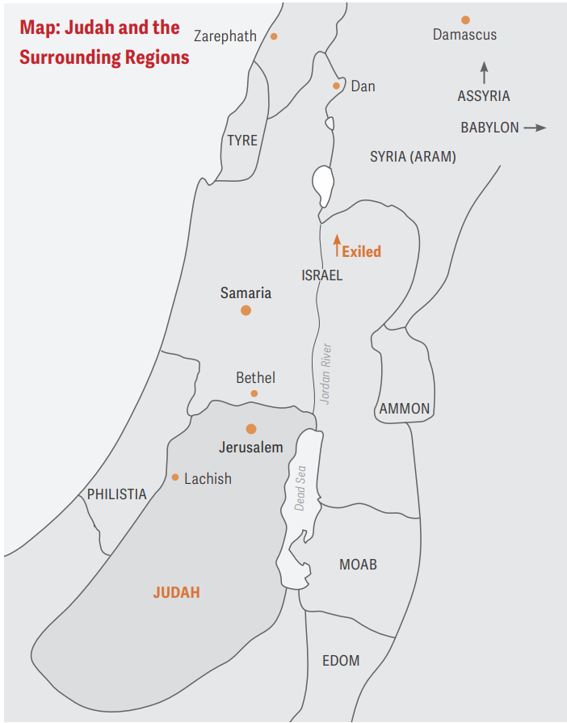

²⁷ “Then tell them, ‘This is what the Lord Almighty, the God of Israel, says: Drink, get drunk and vomit, and fall to rise no more because of the sword I will send among you.’ ²⁸ But if they refuse to take the cup from your hand and drink, tell them, ‘This is what the Lord Almighty says: You must drink it! ²⁹ See, I am beginning to bring disaster on the city that bears my Name, and will you indeed go unpunished? You will not go unpunished, for I am calling down a sword on all who live on the earth, declares the Lord Almighty.’

28 In the fifth month of that same year, the fourth year, early in the reign of Zedekiah king of Judah, the prophet Hananiah son of Azzur, who was from Gibeon, said to me in the house of the Lord in the presence of the priests and all the people: ² “This is what the Lord Almighty, the God of Israel, says: ‘I will break the yoke of the king of Babylon. ³ Within two years I will bring back to this place all the articles of the Lord’s house that Nebuchadnezzar king of Babylon removed from here and took to Babylon. ⁴ I will also bring back to this place Jehoiachin son of Jehoiakim king of Judah and all the other exiles from Judah who went to Babylon,’ declares the Lord, ‘for I will break the yoke of the king of Babylon.’”
⁵ Then the prophet Jeremiah replied to the prophet Hananiah before the priests and all the people who were standing in the house of the Lord. ⁶ He said, “Amen! May the Lord do so! May the Lord fulfill the words you have prophesied by bringing the articles of the Lord’s house and all the exiles back to this place from Babylon. ⁷ Nevertheless, listen to what I have to say in your hearing and in the hearing of all the people: ⁸ From early times the prophets who preceded you and me have prophesied war, disaster and plague against many countries and great kingdoms. ⁹ But the prophet who prophesies peace will be recognized as one truly sent by the Lord only if his prediction comes true.”
¹⁰ Then the prophet Hananiah took the yoke off the neck of the prophet Jeremiah and broke it, ¹¹ and he said before all the people, “This is what the Lord says: ‘In the same way I will break the yoke of Nebuchadnezzar king of Babylon off the neck of all the nations within two years.’” At this, the prophet Jeremiah went on his way.
¹² After the prophet Hananiah had broken the yoke off the neck of the prophet Jeremiah, the word of the Lord came to Jeremiah: ¹³ “Go and tell Hananiah, ‘This is what the Lord says: You have broken a wooden yoke, but in its place you will get a yoke of iron. ¹⁴ This is what the Lord Almighty, the God of Israel, says: I will put an iron yoke on the necks of all these nations to make them serve Nebuchadnezzar king of Babylon, and they will serve him. I will even give him control over the wild animals.’”
¹⁵ Then the prophet Jeremiah said to Hananiah the prophet, “Listen, Hananiah! The Lord has not sent you, yet you have persuaded this nation to trust in lies. ¹⁶ Therefore this is what the Lord says: ‘I am about to remove you from the face of the earth. This very year you are going to die, because you have preached rebellion against the Lord.’”
¹⁷ In the seventh month of that same year, Hananiah the prophet died.

