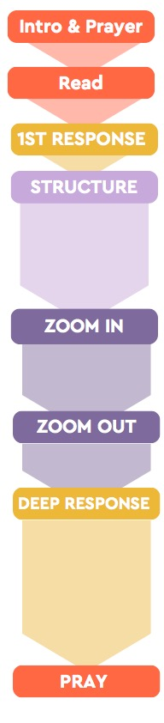
How do you think God is calling you to respond to this passage?
in your faith, your life, or your week?
Do you think you could explain the gospel in a clear way to a friend? How might this passage encourage us to know the gospel clearly?
How might gospel priority look in a Christian’s life today? What might it look like for you? [2 minutes of quiet thinking time, then share]
Suggestions or prompts.
What are the key parts to understand vs16-17?
How might these ideas connect?
As we zoom out, what seems to be at the heart of this passage for us?
In what ways does the gospel drive Paul? Why is that?
Suggestions or prompts.
a. Paul’s prayers and hopes. Paul’s mission. Things about the gospel.
b. about Paul’s motivation? About God’s people?
[For each part of your breakdown ask questions a. & b. below]
a. What do you notice in this section?
b. What kind of impact could this have?
On them? On us?
Take a couple of minutes on your own to look back through the passage. How could you break it down into smaller parts?
[2-5 minutes of discussion time – whatever the pairs need]
- In pairs, come up with a passage breakdown. What’s in each bit?
[2-5 minutes of discussion time – whatever the pairs need]
- Let’s have a couple of pairs share their passage breakdown. What’s in each bit?
[Ask 1-2 specific pairs, then pick a breakdown to work with]
[Two sections work well, 1:8-13 & 1:14-17]
From a first read, what are some things you found interesting?
What seems important? What questions do you have?
Read Romans 1:8-17
What’s something that impacted you from reading the Bible or the sermon?
Pray for our mission partners and your time in the Bible

